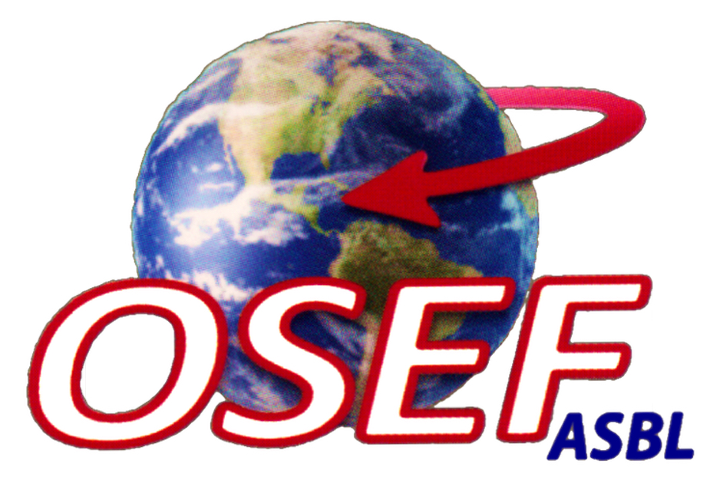

**www.osef.ca**

**PARTICIPATE IN A RECIPROCAL EXCHANGE IN FRANCE, BELGIUM OR SPAIN**

Host your European partner, live with a European family!

Attend school the following year.

**STUDENTS FROM 13 TO 17 YEARS OLD**

***Applications close on May 15, 2016***

**INDIVIDUAL RECIPROCAL EXCHANGES FOR:**

**4 (summer) OR 11 WEEKS (school exchange)**

The **European** students are in Canada from August to October or November (depending on the arrival date).

The **Canadians** students are in France, Belgium or Spain from February to May (depending on the arrival date).

For the **one month summer program**, Canadian students are in Europe for July and return at the end of July with their exchange partner to spend August in Canada.

Students attend an orientation session during a week-end in May or June in order to prepare for a successful exchange.

The program includes 2 days of visits and orientation in Paris (the Eiffel Tower, a boat ride on the Seine River, Notre Dame and the Champs Elysées) and Hotel accommodation.

September/October: the European students attend their partner’s school and at the end of the exchange students receive a report card from their school.

The partners and their families are selected according to interest, age, and personal activities.

The students are covered by a health and repatriation insurance with Tokio Marine.

30 French/Spanish students are waiting for a partner to share this wonderful experience with you!

**The principal’s permission is compulsory to take part in the 9 or 11 weeks exchange.**

**OSEF New Brunswick**

**Kathleen Kiely**

**12 Poets Lane**

**Fredericton NB E3B 9P7**

**506-449-1521** [kathleenkiely@hotmail.com](mailto:kathleenkiely@hotmail.com)



**Follow OSEF on Facebook**http://www.facebook.com/OSEFfrca